Collections Assignment
- Write a program to remove the duplicate from ["Hi","Hello","World"."Hello","Good"} and print the values.

package javaassign;
import java.util.ArrayList;
import java.util.LinkedHashSet;
import java.util.List;
import java.util.Set;

public class CollectionDuplicate {

public static void main(String[] args) {
List<String> list = new ArrayList<> ();
list.add("Hi");
list.add("Hello");
list.add("World");
list.add("Hello");
list.add("Good");

Set<String> uniqueValues = new LinkedHashSet<>(list);
System.out.println("Removed Duplicate Values: ");
System.out.println(uniqueValues);
}
}

Output:
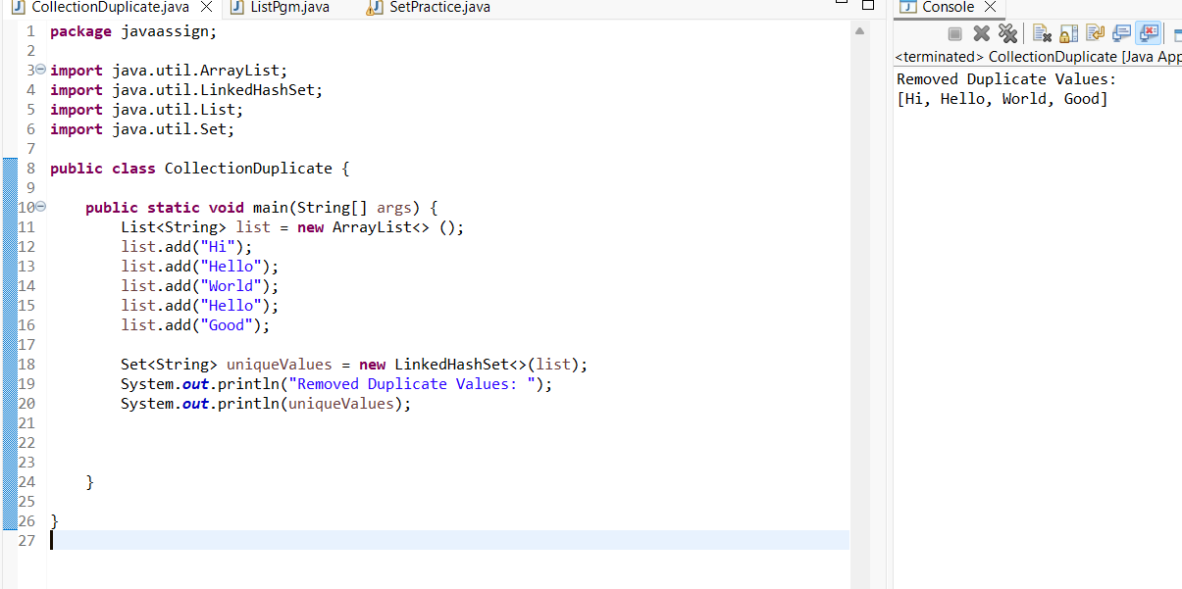

2.Write a program to set student name as a key and student mark will be value. For eg: student name : Devi should return value as 85. Use Map
package javaassign;
import java.util.Map;
import java.util.TreeMap;
public class MapStudentMark {
public static void main(String[] args) {

Map<String,Integer> studentMarks = new TreeMap<>();
studentMarks.put("Raja",90);
studentMarks.put("Maha",80);
studentMarks.put("Mithra",100);
System.out.println(studentMarks);

}

}
Output:
